GYF Company Profile

**GYF Company Profile**

GoYaFace, Inc. (GYF) was incorporated in 2000 and today is a large digital search engine, email/messaging, and internet content company. GYF focuses on three core business units: GYF Search, GYF Mail & Chat, and GYF Digital Media. GYF Search is an internet search platform similar to those offered by [Google](https://www.google.com/) and Microsoft ([Bing](https://www.bing.com/)). GYF Mail & Chat offers email and chat services similar to [Gmail](https://www.google.com/gmail/about/) and Gchat. GYF Digital Media includes several subject-matter specific content destinations, including GYF News, GYF Sports, GYF Business, GYF Style, and GYF Technology. These sites provide original content and interactive features like fantasy football; for example, GYF Sports is comparable to [Yahoo Sports](http://sports.yahoo.com/). GYF has users all over the world and its three core business are offered free of charge to end users.

A major portion of GYF’s revenue comes from selling advertising to other companies who place ads on GYF’s digital services. Originally, this ad-selling business focused on the use of GYF’s digital services and properties at traditional desktops, but recently it has significantly transitioned to mobile advertising as smartphones and other handheld wireless devices have proliferated. Last year, mobile advertising sales accounted for 70% of GYF’s total digital advertising revenue.

GYF’s advertising sales program for its search engine and mail/messaging platforms resembles Google’s “Adwords” program (more information here <https://www.google.com/adwords/>), while its advertising program for its Digital Media content such as news, sports, etc. resembles YouTube’s advertising program (more information here <https://www.youtube.com/yt/advertise/index.html>). GYF users see advertisements as part of their experience on GYF sites and services across devices, as well as some third-party apps and affiliated sites.

GYF competes with Yahoo, Google, Microsoft, and Facebook. You should assume that adblocking poses similar issues for GYF as it does for these companies.

Subject to the above, GYF’s business model most closely resembles Yahoo’s business model as it existed in 2015 and early 2016. If you believe you need to know something specific about GYF’s business and it is not explicit or implicit in the above, feel free to assume that that aspect of GYF’s business resembles the corollary at Yahoo.

Application Exercise 1 – Recommending Customer Analytics Research Methods to Explore Your Problem

***The following "Application Exercise" is intended to be an opportunity for you to practice applying a specific concept from one of the Business Analytics Specialization courses. You are not required to complete it to pass this Capstone, but you should receive at least one additional "point" on your peer review score if you do provide a response. Make sure to include your response as part of the pdf slides you upload to be peer reviewed for this Module - you'll see a placeholder where you can put your response in the***[***project template***](https://www.coursera.org/learn/wharton-capstone-analytics/supplement/0KzDY/project-template)***.***

In Module 1 of the Customer Analytics course (“Descriptive Analytics”), Professor Iyengar explains that there are three basic modes of research in descriptive customer analytics – exploratory research, descriptive research, and causal research. Recall this slide from the lectures:

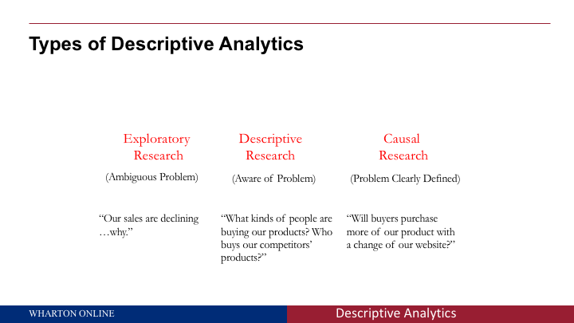

For this first Application Exercise, please work on the questions below, and incorporate your answers into the Problem Statement slides you submit for the Module 2 assignment:

**1. Given your definition of the problem faced by GYF, what type(s) of research will you employ to learn more about the strategy the DATA Team should pursue – exploratory, descriptive, and/or causal? Why?**

**2. What tools could you use to conduct this research?**

Recall, the research tools discussed by Professor Iyengar include:

· Focus groups

· Internet communities (MROCs)

· Surveys (traditional)

· Surveys (mobile)

· Customer self-reporting

· Scanner data (traditional scanner data is unlikely to be directly applicable to the adblocking phenomenon, but the more general mode of data collection represented by scanner data may hold valuable insights)

· Media planning firms

· Social media analytics

· Mobile data analytics

· A/B testing

· Pricing analysis

You might also identify other methods in your own research.

Keep in mind, there are potentially **two** populations that GYF would need to understand better in order to form its adblocking strategy: first, the business that purchase mobile and internet ads to be displayed with GYF’s content; second, the end users who consume GYF’s services (i.e., the people who use its search engine or read its news content). For more on the distinction between these two populations, consider this article: <http://businessmodelalchemist.com/blog/2010/07/users-vs-customers.html>.

Your response to this exercise could include things like the following: What data analysis firms will you employ to gather data about your problem? What population would you survey, and what would you ask? What kinds of social media activity would you be interested in tracking? These are just examples – your specific answers will depend on how you frame your problem.

**There is no “correct” answer to this exercise.** Your goals should be to demonstrate that you understand the concepts of exploratory, descriptive, and causal research and the role data plays in them, and to thoughtfully apply that knowledge to your Problem Statement.

Application Exercise 2 - Using People Analytics Methods to Hire a Leader to Implement Your Strategy

***The following "Application Exercise" is intended to be an opportunity for you to practice applying a specific concept from one of the Business Analytics Specialization courses. You are not required to complete it to pass this Capstone, but you should receive one additional "point" on your peer review score if you do provide a response. Make sure to include your response as part of the pdf slides you upload to be peer reviewed for this Module - you'll see a placeholder where you can put your response in the***[***project template***](https://www.coursera.org/learn/wharton-capstone-analytics/supplement/0KzDY/project-template)***.***

Assume that, as the leader of the DATA Team at GYF, you are looking for a new Senior Associate Director for Digital Advertising Strategy. This person will be your second-in-command as you develop and implement your strategy for addressing the problem of adblocking.

The hiring process has winnowed the field down to two final candidates: (i) Carrie Candidate and (ii) Peggy Prospect.

Below are the metrics upon which the hiring decision will be made:

|  |  |  |
| --- | --- | --- |
| **Metric** | **Carrie Candidate** | **Peggy Prospect** |
| **Background/Experience** | In 2008, Carrie graduated from a Top 10 undergraduate institution in the United States with a degree in Communications and a 3.5 GPA. She then worked for a software company in the marketing department for three years before returning to school to earn her MBA, also at a highly ranked school. For the past several years, she has been a Senior Digital Marketing Manager at a large bank; she has dealt extensively with mobile advertising on the ad-buying side, but has little experience on the ad-selling side. | In 2008, Peggy graduated from a Top 50 undergraduate institution in the United States with a degree in Organizational Leadership and a 3.8 GPA. She then moved to Silicon Valley and worked for a series of digital content startups, such as a site that aggregated news content. In her most recent role at a larger digital media company, which is under many of the same pressures as GYF, she was a Digital Content Manager. As part of her role she specifically focused on the issues posed by adblockers and other technologies that disrupt the traditional delivery of online advertising. |
| **Work samples** | Carrie provided excellent work samples; her work product is polished and shows a knack for creative problem solving. | Peggy provided good work samples that showed a mindset for organization and efficiency. Her samples were less dynamic than Carrie’s. |
| **Cognitive ability tests** | Carrie scored 90% on the cognitive ability test that GYF gives to all management-level applicants. | Peggy scored 75% on the same test. |
| **Structured interview** | Carrie performed well in her structured interview. Her answers were clear and engaging, though not always directly responsive. | Peggy performed very well in her interview. Not only did she demonstrate a deep knowledge of the digital advertising landscape, she exhibited a personality that will fit well with the other members of the DATA Team. |
| **Job knowledge test** | Carrie struggled on the job knowledge test. Although she has a strong grounding in general marketing strategy, she didn’t show a strong understanding of GYF’s business model. | Peggy excelled in the job knowledge test, showing a strong familiarity with the kinds of tasks she would be assigned in her new position. |
| **Integrity test** | Carrie and Peggy achieved the same high score on GYF’s integrity test. | Carrie and Peggy achieved the same high score on GYF’s integrity test. |
| **Personality test** | In her personality test, Carrie scored highly on things like being goal-oriented, hard-driving, and creative. | In her personality test, Peggy scored highly on things like being detail-oriented, open minded, and able to work as part of a team. |
| **References** | Carrie received excellent feedback from references. | Peggy received solid feedback from her references, though one mentioned that Peggy could sometime be “too focused on the short term rather than the long term.” |

**Using the methods introduced in the People Analytics course, in particular Module 2 (“Staffing“), please explain which person you would hire and why, and incorporate your response as part of the Strategy slides submitted for Module 3’s peer review.**

**There is no “correct” answer to this question**; what’s important is to show that you are able approach the question with an analytical mindset and base your decision on the data outlined above.

## Application Exercise 3 - Using Operations Analytics Methods to Understand the Allocation of Scarce Resources in Pursuing a Strategy

***The following "Application Exercise" is intended to be an opportunity for you to practice applying a specific concept from one of the Business Analytics Specialization courses. You are not required to complete it to pass this Capstone, but you should receive one additional "point" on your peer review score if you do provide a response. Make sure to include your response as part of the pdf slides you upload to be peer reviewed for this Module - you'll see a placeholder where you can put your response in the***[***project template***](https://www.coursera.org/learn/wharton-capstone-analytics/supplement/0KzDY/project-template)***.***

Assume that an important part of executing your strategy in addressing adblocking will be efficiently allocating the limited resources of the DATA team. Recall that in Module 2 in Operations Analytics (“Prescriptive Analytics: Making the Best Decisions in Settings with Low Uncertainty”), Professor Savin explained how a simple resource allocation and optimization model can be constructed with only three essential pieces: decision variables, constraints, and an objective that you want to maximize or minimize.

Your task in this Application Exercise is to build a resource allocation and optimization model. Your model could be based on the scenario below, or one of your own design.

The scenario below is provided for those who wish to practice building a resource allocation without providing original numbers. But you should feel free to adapt this model to fit your strategy. Any model included in your “Effects” section that utilizes the concepts of decision variables, constraints, and an objective, will “count” as a completion of Application Exercise 3.

**Optimization Model Scenario**

GYF has a robust training program. Two of its training programs are known as the “Hard Skills Program” and the “Soft Skills Program.” Each of these trainings has two sub-programs: “External” (focusing on employee tasks mainly dealing with clients and customers outside GYF) and “Internal” (focusing on employee tasks mainly dealing with fellow GYF employees). As the leader of the DATA team, you can enroll your employees in these training programs, but you must decide how to best allocate your training budget of $65,000 among these four training options (Hard Skills/External, Hard Skills/Internal, Soft Skills/External, and Soft Skills/Internal).

You decide to base this decision on productivity return rates. GYF’s management has calculated that the productivity return (i.e., the expected extra productivity in the next period, in the equivalent of U.S. dollars, that is achieved for each U.S. dollar spent on training, net of training cost) is proportional to the amount of money spent on training and can be expressed as follows:

|  |  |  |
| --- | --- | --- |
|  | Hard Skills | Soft Skills |
| Internal | 0.2 | 0.6 |
| External | 0.7 | 0.4 |

This means that $10,000 spent on the Internal Hard Skills Program results in $2,000 worth of increased productivity in the next period. This return is cumulative, meaning that if you spent $10,000 on the Internal Hard Skills Program and $10,000 on the External Soft Skills Program, your total dollar return in productivity increases would be 10000*.2+10000*.4.

You need to decide how much of your budget to spend on each type of training to maximize the total productivity return. But you can’t simply spend all your budget on the type of training with the highest return, because there are three requirements (in addition to staying within your budget) that management is requiring you to satisfy in allocating your training budget. They are:

* The Hard Skills training program must achieve at least $20,000 in the total net productivity increase;
* The Soft Skills training program must achieve at least $12,000 in the total net productivity increase; and
* The Internal program should achieve at least 60% of the net productivity increase realized for the External program.

Assume all these figures are “deterministic” – known, and non-random.

Your task for this Application Exercise is to follow the steps outlined in Module 2 of the Operation Analytics course to:

**1. Algebraically express the various relationships between the factors outlined above; and**

**2. Use a spreadsheet application like Excel and a function like Solver to allocate your budget in a way that maximizes the productivity return (i.e., determine what amount of the budget, if any, should be spent on each of the four types of training to maximize productivity, subject to the constraints).**

You’re encouraged to build the spreadsheet from scratch, but a template spreadsheet is provided at the “Application Exercise 3 Spreadsheet” link in Module 4 for those who would like to use it.

Include your answers to these questions, and an explanation of the steps you followed, in the Slides you upload for the Module 4 assignment.

**While there are numbers to be derived from Solver, your focus should be less on the math and more on demonstrating that you understand the significance of the concepts of decision variables, constraints, and objectives in your strategic thinking.**

Application Exercise 4 - Using Accounting Analytics Methods to Measure the Key Drivers of Your Proposed Strategy

***The following "Application Exercise" is intended to be an opportunity for you to practice applying a specific concept from one of the Business Analytics Specialization courses. You are not required to complete it to pass this Capstone, but you should receive one additional "point" on your peer review score if you do provide a response. Make sure to include your response as part of the pdf slides you upload to be peer reviewed for this Module - you'll see a placeholder where you can put your response in the***[***project template***](https://www.coursera.org/learn/wharton-capstone-analytics/supplement/0KzDY/project-template)***.***

In Module 4 of the Accounting Analytics course, Professor Ittner introduced the concept of the “causal business model” as a tool for measuring performance. Recall this slide from Lecture 4.2 regarding the first step in constructing such a model:

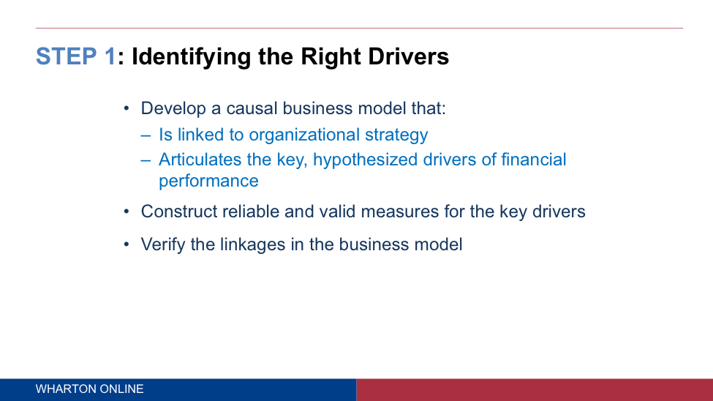

In this Application Exercise, your task is to apply the framework from this slide to your proposed strategy. Remember, one of the key insights in this framework is that your strategy must have a specific goal that you are trying to achieve and must be explicitly causal: A will lead to B will lead to C, etc.

To complete this exercise, you should include in the “Measurement” section of your presentation a slide (or slides) that goes through the following three-step analysis:

**1. Identify at least one hypothesis that is explicitly linked to your strategy in a causal way.**

As explained in Professor Ittner’s lecture: "*What the causal business model is trying to do is saying, here's what I'd like to achieve, what are the steps that I need to take to successfully implement this strategy, see if it works, and see if ultimately it leads to financial performance, and the way we're going to do that is we're going to articulate these hypothesized drivers. This causal thing. A leads to B leads to C, those are hypothesis. For each one of those A, Bs and Cs we're going to come up with financial or nonfinancial performance measures and see if ultimately do they translate through the way we think it's going to."*

**2. Identify at least one key driver and explain how that driver will be measured as your strategy is implemented.**

As explained in Professor Ittner’s lecture, this involves: "*Second thing we have to do is construct what are called reliable and valid measures of the key drivers. Basically, do these measures pick up what you think they're picking up? Our strategy says, do A, do B, do C. The question is, how do I measure A?* "

**3. Describe how you would go about verifying the linkage between the first two steps.**

As explained in Professor Ittner’s lecture, this involves: "*I got a causal business model. I had some constructs or measures that I think actually capture the dimensions I care about. Let's verify the linkages. Let's see if it's actually true, because again, we're guessing here. The strategic plan may be based on your intuition or whatever. It is a hypothesis about how things are going to work. Let's verify, if I said A should lead to B should lead to C, let's verify this. Let's do some analytics on this to see if these linkages that you hypothesized actually show up. But again, I want to know why, because if they aren't either I gotta change my measures, change my strategy or figure out what are the organizational barriers that are blocking this from happening."*

Given that this is a hypothetical exercise, you may not be able to actually test a hypothesis, but you should explain in your presentation how your hypothesis could be measured and what data would need to be collected and analyzed.

**There is no “correct” answer for this exercise**; what’s important is to show that you are able to approach the task with an analytical mindset that is based on causal thinking and linking measurement and outcomes.